Get sample code for this lab

Get the sample code for creating and running containers and deployments:

gsutil -m cp -r gs://spls/gsp053/orchestrate-with-kubernetes .

cd orchestrate-with-kubernetes/kubernetes

Copied!

content_copy

Create a cluster with five n1-standard-1 nodes (this will take a few minutes to complete):

gcloud container clusters create bootcamp --num-nodes 5 --scopes "https://www.googleapis.com/auth/projecthosting,storage-rw"

Copied!

content_copy

**Learn about the deployment object**

Let's get started with Deployments. First let's take a look at the Deployment object. The explain command in kubectl can tell us about the Deployment object.

kubectl explain deployment

Copied!

content_copy

We can also see all of the fields using the --recursive option.

kubectl explain deployment --recursive

Copied!

content_copy

You can use the explain command as you go through the lab to help you understand the structure of a Deployment object and understand what the individual fields do.

kubectl explain deployment.metadata.name

Copied!

content_copy

**Create a deployment**

Update the deployments/auth.yaml configuration file:

vi deployments/auth.yaml

Copied!

content_copy

Start the editor:

i

Copied!

content_copy

Change the image in the containers section of the Deployment to the following:

...

containers:

- name: auth

image: "kelseyhightower/auth:1.0.0"

...

Copied!

content_copy

Save the auth.yaml file: press <Esc> then type:

:wq

Copied!

content_copy

Press <Enter>. Now let's create a simple deployment. Examine the deployment configuration file:

cat deployments/auth.yaml

Copied!

content_copy

(Output)

apiVersion: apps/v1

kind: Deployment

metadata:

name: auth

spec:

replicas: 1

selector:

matchLabels:

app: auth

template:

metadata:

labels:

app: auth

track: stable

spec:

containers:

- name: auth

image: "kelseyhightower/auth:1.0.0"

ports:

- name: http

containerPort: 80

- name: health

containerPort: 81

...

Notice how the Deployment is creating one replica and it's using version 1.0.0 of the auth container.

When you run the kubectl create command to create the auth deployment, it will make one pod that conforms to the data in the Deployment manifest. This means we can scale the number of Pods by changing the number specified in the replicas field.

Go ahead and create your deployment object using kubectl create:

kubectl create -f deployments/auth.yaml

Copied!

content_copy

Once you have created the Deployment, you can verify that it was created.

kubectl get deployments

Copied!

content_copy

Once the deployment is created, Kubernetes will create a ReplicaSet for the Deployment. We can verify that a ReplicaSet was created for our Deployment:

kubectl get replicasets

Copied!

content_copy

We should see a ReplicaSet with a name like auth-xxxxxxx

Finally, we can view the Pods that were created as part of our Deployment. The single Pod is created by the Kubernetes when the ReplicaSet is created.

kubectl get pods

Copied!

content_copy

It's time to create a service for our auth deployment. You've already seen service manifest files, so we won't go into the details here. Use the kubectl create command to create the auth service.

kubectl create -f services/auth.yaml

Copied!

content_copy

Now, do the same thing to create and expose the hello Deployment.

kubectl create -f deployments/hello.yaml

kubectl create -f services/hello.yaml

Copied!

content_copy

And one more time to create and expose the frontend Deployment.

kubectl create secret generic tls-certs --from-file tls/

kubectl create configmap nginx-frontend-conf --from-file=nginx/frontend.conf

kubectl create -f deployments/frontend.yaml

kubectl create -f services/frontend.yaml

Copied!

content_copy

**Note:** You created a ConfigMap for the frontend.

Interact with the frontend by grabbing its external IP and then curling to it.

kubectl get services frontend

Copied!

content_copy

It may take a few seconds before the External-IP field is populated for your service. This is normal. Just re-run the above command every few seconds until the field is populated.

curl -ks https://<EXTERNAL-IP>

Copied!

content_copy

And you get the hello response back.

You can also use the output templating feature of kubectl to use curl as a one-liner:

curl -ks https://`kubectl get svc frontend -o=jsonpath="{.status.loadBalancer.ingress[0].ip}"`

Copied!

content_copy

**Test Completed Task**

Click **Check my progress** below to check your lab progress. If you successfully created Kubernetes cluster and Auth, Hello and Frontend deployments, you'll see an assessment score.

Please create a Kubernetes cluster in us-central1-a zone and create Auth, Hello and Frontend deployments.

Create a Kubernetes cluster and deployments (Auth, Hello, and Frontend)

Check my progress

*Please create a Kubernetes cluster in us-central1-a zone and create Auth, Hello and Frontend deployments.*

Scale a Deployment

Now that we have a Deployment created, we can scale it. Do this by updating the spec.replicas field. You can look at an explanation of this field using the kubectl explain command again.

kubectl explain deployment.spec.replicas

Copied!

content_copy

The replicas field can be most easily updated using the kubectl scale command:

kubectl scale deployment hello --replicas=5

Copied!

content_copy

**Note:** It may take a minute or so for all the new pods to start up.

After the Deployment is updated, Kubernetes will automatically update the associated ReplicaSet and start new Pods to make the total number of Pods equal 5.

Verify that there are now 5 hello Pods running:

kubectl get pods | grep hello- | wc -l

Copied!

content_copy

Now scale back the application:

kubectl scale deployment hello --replicas=3

Copied!

content_copy

Again, verify that you have the correct number of Pods.

kubectl get pods | grep hello- | wc -l

Copied!

content_copy

You learned about Kubernetes deployments and how to manage & scale a group of Pods.

**Rolling update**

Deployments support updating images to a new version through a rolling update mechanism. When a Deployment is updated with a new version, it creates a new ReplicaSet and slowly increases the number of replicas in the new ReplicaSet as it decreases the replicas in the old ReplicaSet.

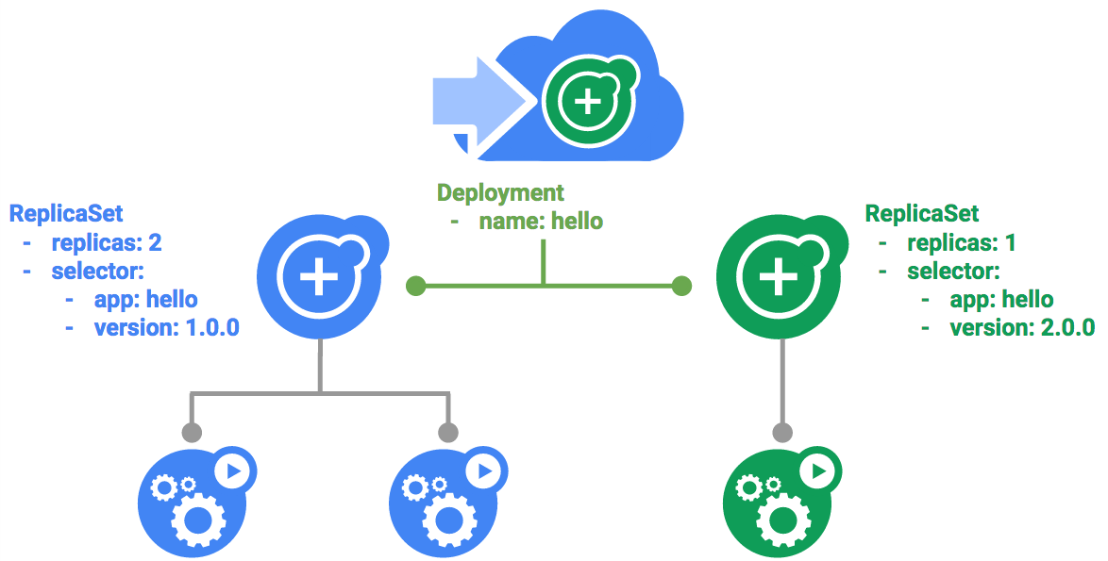

Trigger a rolling update

To update your Deployment, run the following command:

kubectl edit deployment hello

Copied!

content_copy

Change the image in the containers section of the Deployment to the following:

...

containers:

image: kelseyhightower/hello:2.0.0

...

Copied!

content_copy

Save and exit.

Once you save out of the editor, the updated Deployment will be saved to your cluster and Kubernetes will begin a rolling update.

See the new ReplicaSet that Kubernetes creates.:

kubectl get replicaset

Copied!

content_copy

You can also see a new entry in the rollout history:

kubectl rollout history deployment/hello

Copied!

content_copy

Pause a rolling update

If you detect problems with a running rollout, pause it to stop the update. Give that a try now:

kubectl rollout pause deployment/hello

Copied!

content_copy

Verify the current state of the rollout:

kubectl rollout status deployment/hello

Copied!

content_copy

You can also verify this on the Pods directly:

kubectl get pods -o jsonpath --template='{range .items[*]}{.metadata.name}{"\t"}{"\t"}{.spec.containers[0].image}{"\n"}{end}'

Copied!

content_copy

Resume a rolling update

The rollout is paused which means that some pods are at the new version and some pods are at the older version. We can continue the rollout using the resume command.

kubectl rollout resume deployment/hello

Copied!

content_copy

When the rollout is complete, you should see the following when running the status command.

kubectl rollout status deployment/hello

Copied!

content_copy

(Output)

deployment "hello" successfully rolled out

Rollback an update

Assume that a bug was detected in your new version. Since the new version is presumed to have problems, any users connected to the new Pods will experience those issues.

You will want to roll back to the previous version so you can investigate and then release a version that is fixed properly.

Use the rollout command to roll back to the previous version:

kubectl rollout undo deployment/hello

Copied!

content_copy

Verify the roll back in the history:

kubectl rollout history deployment/hello

Copied!

content_copy

Finally, verify that all the Pods have rolled back to their previous versions:

kubectl get pods -o jsonpath --template='{range .items[*]}{.metadata.name}{"\t"}{"\t"}{.spec.containers[0].image}{"\n"}{end}'

Copied!

content_copy

Great! You learned about rolling updates for Kubernetes deployments and how to update applications without downtime.

**Canary deployments**

When you want to test a new deployment in production with a subset of your users, use a canary deployment. Canary deployments allow you to release a change to a small subset of your users to mitigate risk associated with new releases.

Create a canary deployment

A canary deployment consists of a separate deployment with your new version and a service that targets both your normal, stable deployment as well as your canary deployment.

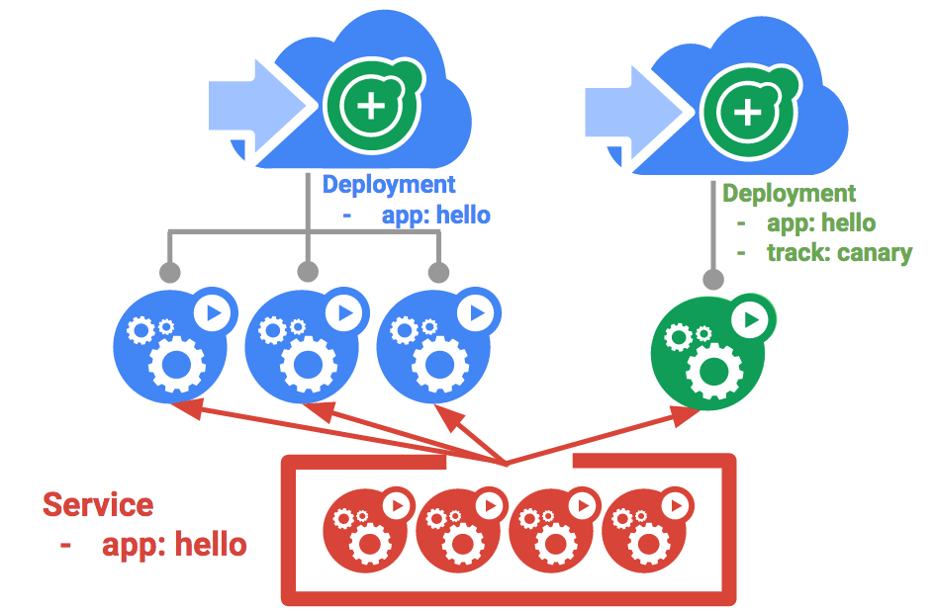

First, create a new canary deployment for the new version:

cat deployments/hello-canary.yaml

Copied!

content_copy

(Output)

apiVersion: apps/v1

kind: Deployment

metadata:

name: hello-canary

spec:

replicas: 1

selector:

matchLabels:

app: hello

template:

metadata:

labels:

app: hello

track: canary

# Use ver 2.0.0 so it matches version on service selector

version: 2.0.0

spec:

containers:

- name: hello

image: kelseyhightower/hello:2.0.0

ports:

- name: http

containerPort: 80

- name: health

containerPort: 81

...

Now create the canary deployment:

kubectl create -f deployments/hello-canary.yaml

Copied!

content_copy

After the canary deployment is created, you should have two deployments, hello and hello-canary. Verify it with this kubectl command:

kubectl get deployments

Copied!

content_copy

On the hello service, the selector uses the app:hello selector which will match pods in **both** the prod deployment and canary deployment. However, because the canary deployment has a fewer number of pods, it will be visible to fewer users.

Verify the canary deployment

You can verify the hello version being served by the request:

curl -ks https://`kubectl get svc frontend -o=jsonpath="{.status.loadBalancer.ingress[0].ip}"`/version

Copied!

content_copy

Run this several times and you should see that some of the requests are served by hello 1.0.0 and a small subset (1/4 = 25%) are served by 2.0.0.

**Test Completed Task**

Click **Check my progress** below to check your lab progress. If you successfully created Canary deployment, you'll see an assessment score.

Assessment Completed!

Canary Deployment

Check my progress

*Assessment Completed!*

Canary deployments in production - session affinity

In this lab, each request sent to the Nginx service had a chance to be served by the canary deployment. But what if you wanted to ensure that a user didn't get served by the Canary deployment? A use case could be that the UI for an application changed, and you don't want to confuse the user. In a case like this, you want the user to "stick" to one deployment or the other.

You can do this by creating a service with session affinity. This way the same user will always be served from the same version. In the example below the service is the same as before, but a new sessionAffinity field has been added, and set to ClientIP. All clients with the same IP address will have their requests sent to the same version of the hello application.

kind: Service

apiVersion: v1

metadata:

name: "hello"

spec:

sessionAffinity: ClientIP

selector:

app: "hello"

ports:

- protocol: "TCP"

port: 80

targetPort: 80

Due to it being difficult to set up an environment to test this, you don't need to here, but you may want to use sessionAffinity for canary deployments in production.

**Blue-green deployments**

Rolling updates are ideal because they allow you to deploy an application slowly with minimal overhead, minimal performance impact, and minimal downtime. There are instances where it is beneficial to modify the load balancers to point to that new version only after it has been fully deployed. In this case, blue-green deployments are the way to go.

Kubernetes achieves this by creating two separate deployments; one for the old "blue" version and one for the new "green" version. Use your existing hello deployment for the "blue" version. The deployments will be accessed via a Service which will act as the router. Once the new "green" version is up and running, you'll switch over to using that version by updating the Service.

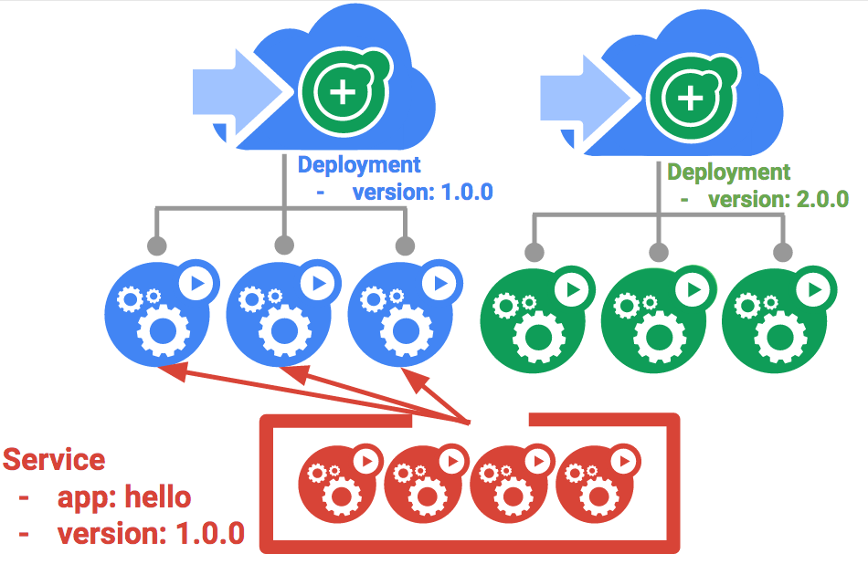

A major downside of blue-green deployments is that you will need to have at least 2x the resources in your cluster necessary to host your application. Make sure you have enough resources in your cluster before deploying both versions of the application at once.

The service

Use the existing hello service, but update it so that it has a selector app:hello, version: 1.0.0. The selector will match the existing "blue" deployment. But it will not match the "green" deployment because it will use a different version.

First update the service:

kubectl apply -f services/hello-blue.yaml

Copied!

content_copy

**NOTE:** Ignore the warning that says resource service/hello is missing as this is patched automatically.

Updating using Blue-Green Deployment

In order to support a blue-green deployment style, we will create a new "green" deployment for our new version. The green deployment updates the version label and the image path.

apiVersion: apps/v1

kind: Deployment

metadata:

name: hello-green

spec:

replicas: 3

selector:

matchLabels:

app: hello

template:

metadata:

labels:

app: hello

track: stable

version: 2.0.0

spec:

containers:

- name: hello

image: kelseyhightower/hello:2.0.0

ports:

- name: http

containerPort: 80

- name: health

containerPort: 81

resources:

limits:

cpu: 0.2

memory: 10Mi

livenessProbe:

httpGet:

path: /healthz

port: 81

scheme: HTTP

initialDelaySeconds: 5

periodSeconds: 15

timeoutSeconds: 5

readinessProbe:

httpGet:

path: /readiness

port: 81

scheme: HTTP

initialDelaySeconds: 5

timeoutSeconds: 1

Copied!

content_copy

Create the green deployment:

kubectl create -f deployments/hello-green.yaml

Copied!

content_copy

Once you have a green deployment and it has started up properly, verify that the current version of 1.0.0 is still being used:

curl -ks https://`kubectl get svc frontend -o=jsonpath="{.status.loadBalancer.ingress[0].ip}"`/version

Copied!

content_copy

Now, update the service to point to the new version:

kubectl apply -f services/hello-green.yaml

Copied!

content_copy

With the service is updated, the "green" deployment will be used immediately. You can now verify that the new version is always being used.

curl -ks https://`kubectl get svc frontend -o=jsonpath="{.status.loadBalancer.ingress[0].ip}"`/version

Copied!

content_copy

Blue-Green Rollback

If necessary, you can roll back to the old version in the same way. While the "blue" deployment is still running, just update the service back to the old version.

kubectl apply -f services/hello-blue.yaml

Copied!

content_copy

Once you have updated the service, your rollback will have been successful. Again, verify that the right version is now being used:

curl -ks https://`kubectl get svc frontend -o=jsonpath="{.status.loadBalancer.ingress[0].ip}"`/version

Copied!

content_copy

You did it! You learned about blue-green deployments and how to deploy updates to applications that need to switch versions all at once.

**Congratulations!**